**Final Report – Your Journal**

# Initial Design Report

Project Proposal – Your Journal

Note: Name is subject to change

# Project Description

## What is the idea behind the website?

Journal writing is becoming more and more popular as people realise the massive mental health benefits of keeping a journal/diary of their thoughts. Multiple studies have shown that people experience less anxiety when they can get their thoughts into paper, or in this case, a website.

## Who are the potential users of the site?

Potentially, almost everyone may keep a journal at some point in their lives. Some may use it just to jot notes down, and some may pour their heart out on the keyboard. People in stressful situations would avail of this service, from students to office workers.

## What are the main features of the website?

1. The ability to create notes with text, and the ability to append images to them. They can also specify a tag for the note, so it can be searched later. Notes can be deleted permanently also.
2. Creating a personal profile, with basic information about yourself and a picture.

# UI Design

Wireframe of the main page of the website.

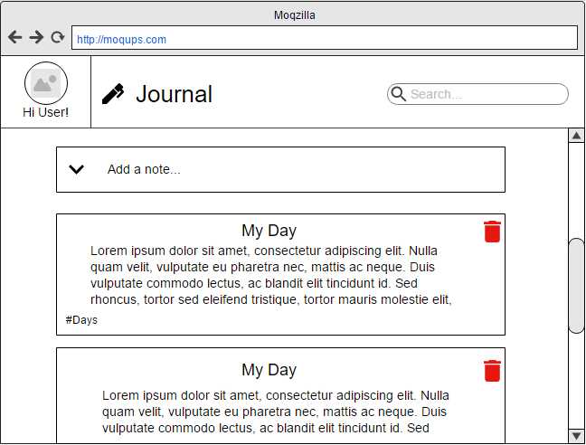

When the page has loaded, the user will be asked for their name and picture. Then they are shown the main page, where they can add a note with an accordion, delete notes, and search notes.

# Component Tree Diagram

Basic Component Tree diagram.

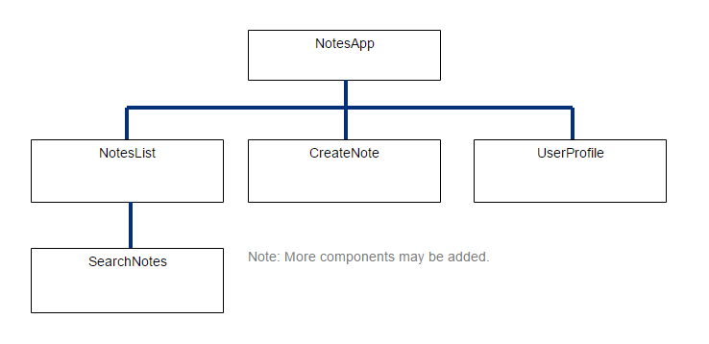

# Architecture Diagram

2 Tier architecture diagram.

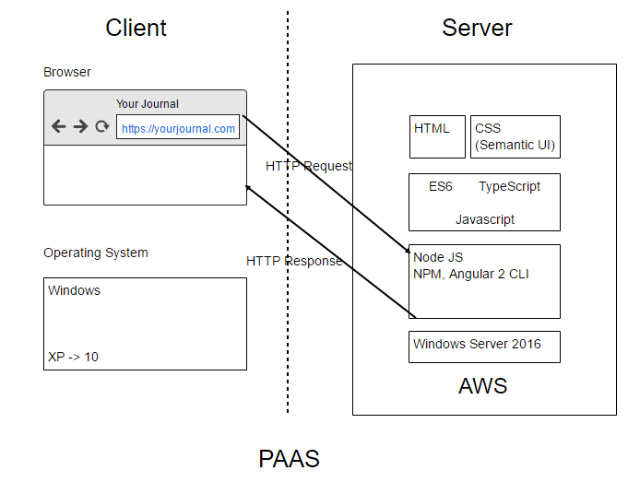

# Components

## app

Shows the display component.

## display

This component is the parent of search, create-note and notes-list. This displays most of the content on the page.

## create-note

This component is the accordion with textboxes, which saves the entered content into an array of notes along with a randomly generated colour.

## notes-list

This shows all the note-rows in a grid.

## note-row

This is a child of notes-list, and displays the notes content in a styled format, also adds a button to remove the note using splice.

## search

This takes user input and passes it back up to the parent, and down to note-row where a method called checks the title, content and tag for the search term.

# Main Elements (Screenshots of Application)

Main page of the application. 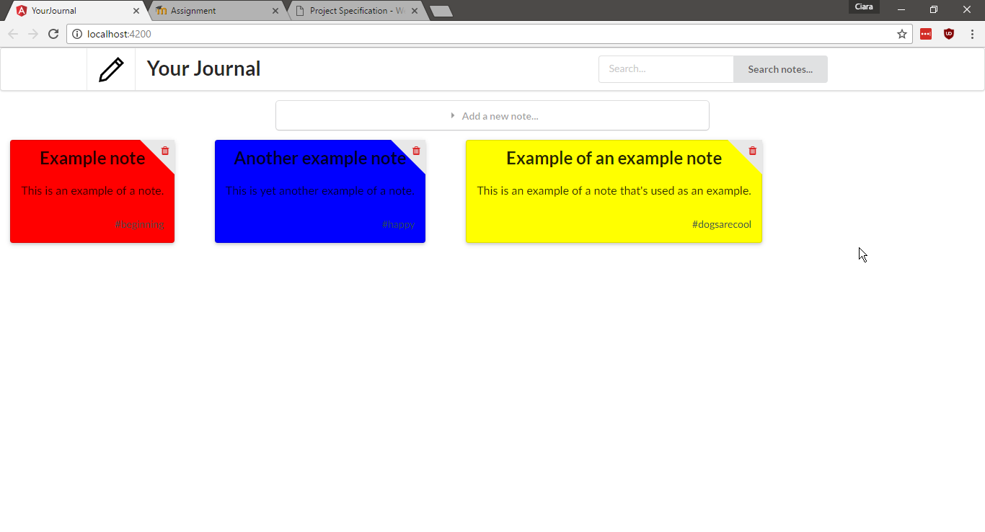

The accordion used to create new notes. 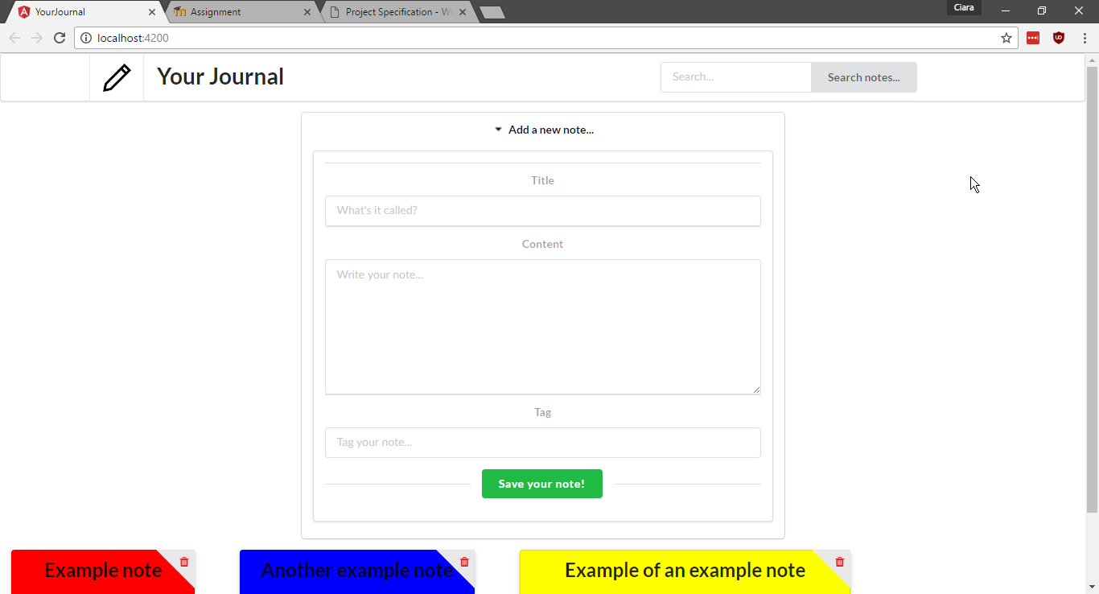

The search being used to find a note with a specific tag.

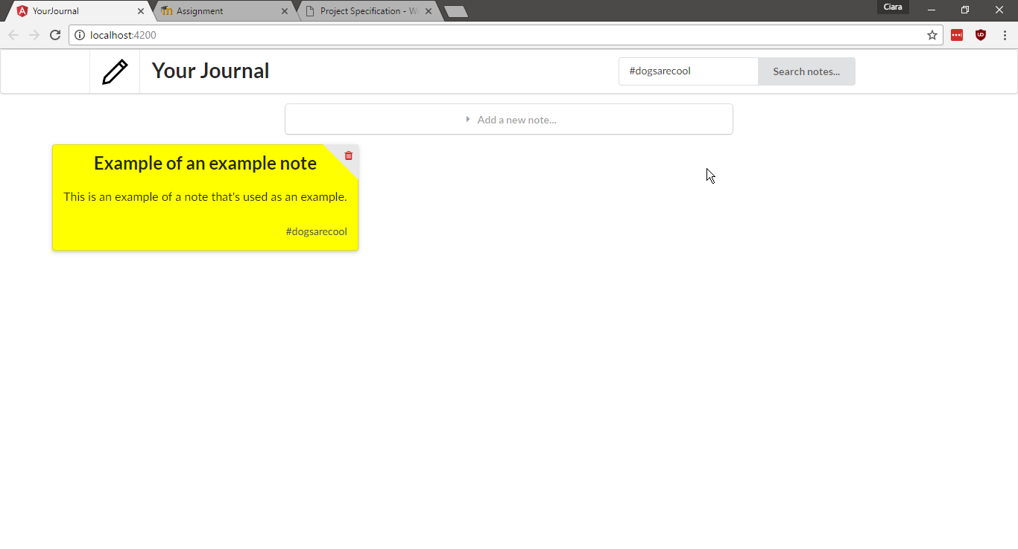

# Main CSS classes used

## title

Used in create-note and note-row to style both the content in the search accordion as well as the note content.

## ui three column grid

Used in notes-list to show all the notes in a grid.

## ui styled accordion field

Used in create-note to create the accordion

## ui fluid input

Used in create-note to style the inputs.

*There are more CSS classes (both Semantic UI and local styling) for individual elements in the project.*

# Reflection

Overall this project wasn’t too bad at all, and I achieved most of what I aimed to do. I was a bit ambitious in my initial report, as you can see I did without the user profile element as well as the ability to add photos to the notes. I did have to rely a lot on previous code for the Reddit app and the inventory app. I found that Semantic UI was helpful, but debugging it was a pain as I had to build it using Gulp and therefore rely on their jQuery. I felt a bit lost at the beginning, it’s hard to try to come up with an idea that’s not too big but also not too small. I kept it small because I wanted it to be fully functional at the end of the project.

I struggled with the concept of Event Emitters and emitting data back up to the parents, and found that the online resources could be complicated and not very newbie friendly. I got some help from my classmates and got it working correctly.

Doing this project has helped me understand a lot about core concepts of Angular like data-binding and sub-components. I feel more comfortable coding in Typescript and debugging it. It’ll be useful to have this project as a reference for future projects in Angular 2.

# Self-Evaluation

|  |  |  |
| --- | --- | --- |
|  |  | Ciara Lynch |
|  |  | S00156269 |
| **Proposal (20 Marks)** |  |  |
| Well Written Description | **4** |  |
| User Interface (UI) design | **4** |  |
| Component Tree Diagram | **4** |  |
| Architecture Diagram | **5** |  |
|  |  |  |
|  |  |  |
| **Implementation (60 Marks)** |  |  |
| Tree of Components Created | **15** |  |
| Objects Passed Between Components | **14** |  |
| Good CSS Styling | **12** |  |
| Use of MVC Pattern | **7** |  |
|  |  |  |
| **Screencast (7 Marks)** |  |  |
| Project and key elements well explained | **8** |  |
| **Document (13 Marks)** |  |  |
| Contains proposal, screenshots and CSS explanation. Good reflection. | **10** |  |
|  |  |  |
|  |  |  |
| **Total** | **83** |  |